ICICI BANK LIMITED

SSL Inspection Bypass Risk Assessment

Draft Report dated: Aug 18, 2026
Type of assessment: SSL Inspection Bypass Risk Assessment
Assessor - Mr. Kunal Kumar
Domain Head:  Mr. Vishal Saraswat | Team Leader:  Mr. Manish Srivastava
Manager:  Mr. Omkar Pawar | Advisor:  Mr. Tejbahadur Yadav

Overview:
Request to bypass SSL Inspection for the above URL due to application functionality issues caused by SSL Placement.

Assessment Scope:
The Objective of Assessment is to evaluate implication of granting SSL inspection Bypass for the requested URL, Validate Potential Security Risks arising from reduced Encrypted traffic inspection, assess existing and compensation security controls.

Assessment Objective:
- Evaluating Impact of granting SSL Inspection bypass for URL based on submitted justification.
- To Identify Potential Risks, Assess Existing and compensating controls.

Business Justification:
The application is connected with CERSAI (Govt. Entity) via API to fetch the customer details which
is required during the onboarding customer journey across Bank. We are connected with CERSAI via Bluecoat Proxy where the SSL is bypassed to fetch the details from CERSAI. As part of the migration from Bluecoat to Zscaler proxy, we would like to have the same configuration in place for the CERSAI API connectivity.

Assessment Process:
1. Business Justification
2. Validation of the requestor URL/FQDN
3. Impact of disabling SSL Inspection
4. Security Risk Introduced by Exception
5. Recommendation based on business need and Security Risks

Assessment performed on below URL:
CAN ID: 7486
Application Name: EVENT HUB

SR. No. | URL | URL Category | Server IP | Risk level identified
1 | https://www.ckycindia.in/ | Government | 10.51.7.205 | High

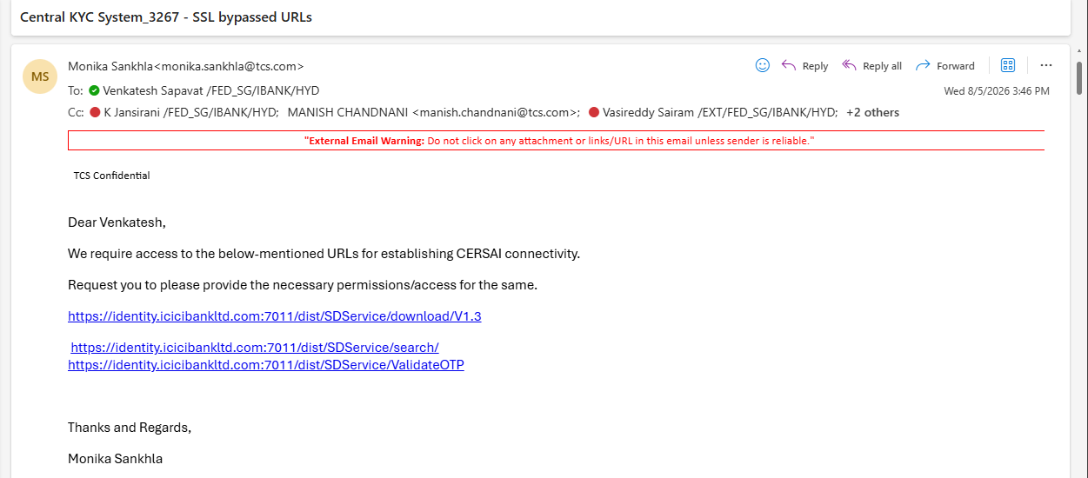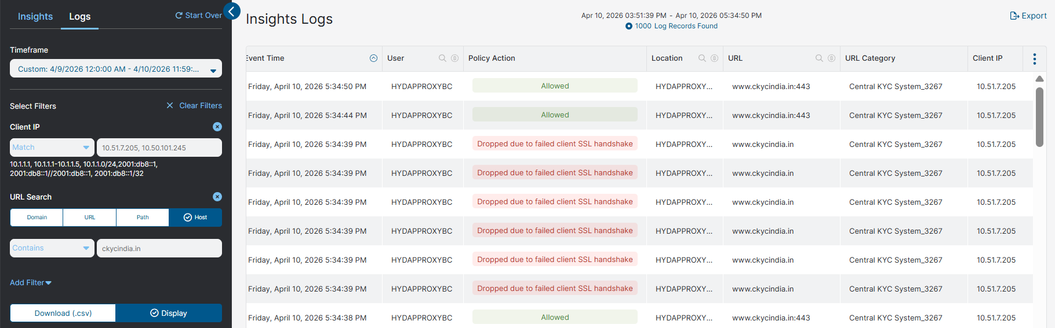

Security Controls Bypass:
- SSL Inspection
- Proxy Malware/File Inspection
- Zscaler DLP
- Upload and Download
- HTTP Header/Body Inspection

Security Risks:

Malware Payloads
Risk : High

Risk Description: Malicious files may carry various types of malwares, such as viruses, worms, Trojans, or ransomware.

Impact: Malware can compromise the integrity of the system, steal sensitive data, or cause disruptions to normal operations.

Command and Control Communication

Risk : High

Risk Description: Malicious files often establish connections with command and control servers.

Impact: Attackers gain remote control over the compromised system, enabling them to execute further malicious activities, exfiltration data, or deploy additional payloads.

Compensation Controls
Following mitigation controls with mail confirmation from respective stakeholders should be attached in iInsight request:

o XDR is installed and running for malicious activity monitoring
o AV is installed and running
o Latest Patches are applied
o System harden as per bank policy
o Restrict SSL Bypass to specific FQDN/URL Only
o Guardicore Micro-Segmentation Should be placed
o DNS Filtering Should be Enabled
o Latest TLS Encrypted communication with Certificate Validation

Pls refer below link to raise the iInsight request.

https://iinsight.icicibankltd.com/exception/riskexception
Acknowledgments | ISG would like to thank respective stake holder and seniors for their co-operation during the assessment.
Note: This SSL Bypass assessment is intended to review risk and evaluate the existence and effectiveness of URL.

